Totaal Software



Preface to using StageRace
Subjected version: 2000.1.20
Date: February 2002

Make your race match 2
Regulations’ compatibility 2
Division of tasks and preparation 3
Afterword 3

This document contains some points of concern before applying the StageRace software product at your event for the first time.
There are some strong warnings enclosed in the information. Even with StageRace available, stage race administration operation remains a responsible task with some potential pitfalls.

Make your race match

You should be aware of what the impact is of starting to use the StageRace software product.
Although StageRace is a very versatile and flexible solution for the administration of stage races, and it is very likely to match with your race, your race also should match with StageRace.

Regulations’ compatibility

A very common expression always is ‘UCI compatibility’. StageRace certainly is compatible with all the applicable UCI regulations that were available during the development.
This raises the impression that StageRace can be applied trouble-free at any race that is run under UCI regulations.
Ultimately, however, only very few details are unambiguously regulated by the UCI. All the other procedures, protocols, calculation methods, etc. are often covered in an exceptional rules guide that is event-specific.
Therefore, race organisers have a considerable freedom for filling in a lot of things that are not covered by the UCI and they quite often also even override UCI regulations in their rules guide.

As a solution for the items that are not covered in the UCI regulations, we rely on the practical experiences while applying StageRace beta versions at many races throughout mainly the Netherlands and Germany.
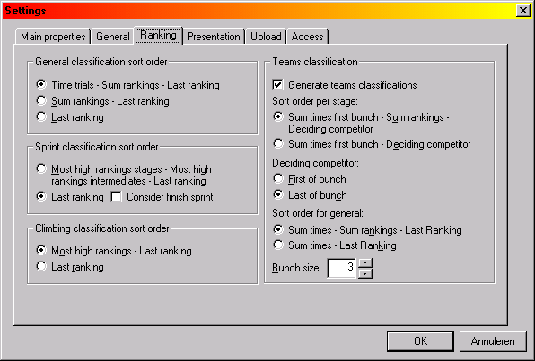
And in order to come forward to exceptional regulations, StageRace offers configuration possibilities for a limited number of alternatives or overrides. (For instance in the Ranking settings, see the image.)
In order to make sure that you do not get into trouble due to incompatible regulations for a specific race, you should best compare StageRace’s capabilities to the race requirements at a very early point. You might even want to submit your regulations draft to StageRace Support in order to be sure that you will be able to handle your race event with StageRace.
In the experiences with the beta versions it hardly ever happened that the sportive objectives for the race had to be compromised. Regulation details, however, had to be adjusted regularly. The day of the race often is much too late for this.

Division of tasks and preparation

It is a good thing to make a division into (the moment of execution of) the following tasks.
Configuring of an event | This can be done in the period preceding to the event, in cooperation with an organization representative.  As explained before, the applied regulations have to be set, but also the race details that appear on the publications, the points and bonuses for spints and of course the configuration of stages and half stages.
Utilisation of an event | This takes place during the happening of the various stages, in cooperation with the members of the jury which are present.  Although StageRace can make your work as a race administrator much and much easier, any operator of the software should still know about the details, therefore knowing about the regulations and calculation methods for stage races.  We think, as a rule of thumb, that an operator should be required to exercise with building and running at least one entire race event, for instance based on the last edition’s data of the first race (s)he’s going to do.  The software can only be as good as its operator.

Afterword

You will surely grow in using StageRace, while using the information from this document as well as the other support resources and you will soon appreciate all of StageRace’s possibilities!

